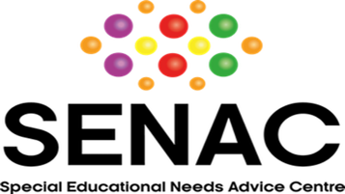

SENAC seeks to appoint Board Members

Special Educational Needs Advice Centre (SENAC) is seeking to appoint new Trustees to join its Board of Directors.
This is a great opportunity to share your talents and expertise, and to help make a positive, long-lasting impact on the lives of children and young people with special educational needs in Northern Ireland.
SENAC is a charity that provides confidential, independent advice and advocacy for children and young people with disabilities and special educational needs (SEN) who attend schools in Northern Ireland up to the age of 19 years.
Since its inception in 2003, SENAC has helped thousands of children to receive a standard of education that would not otherwise have been available to them without intervention. The charity has been supporting and advising parents on how to access education support for children with additional needs through a range of regional services which include an Advice Line, Advocacy and Appeal services and Community workshops.
Demand for our services is extremely high; we receive referrals from over 100 different organisations, agencies, and professionals, and on average, we support over 1,000 families each year at current capacity.
We are currently seeking volunteers to come on board with the team and make a difference to the lives of countless children across Northern Ireland.
One of the most powerful ways to contribute to your community or support a cause you care about, is to become a trustee of a charity. It’s a role which will give back as much as you put in. SENAC is expanding its Management Board and is looking for new members who will bring fresh ideas and new perspectives to the charity.
As a member of the Board, you will play an integral part in the good governance of the charity. Not only ensuring that the organisation remains viable and sustainable, but also ensuring that it follows its mission and continues to work in the interests of children and young people, and their parents. Fundraising strategy and income generation are important aspects of the role.
We would be particularly keen to hear from applicants with skills in strategy, business development, fundraising, marketing, finance, or HR. However, in general, we aim to expand the skill set of our Board to reflect the diversity and experiences of our beneficiaries.
Background/experience in one or more of the following relevant areas would be desirable:
- Finance, HR, education, law, sales and marketing
- Health, family support
- Voluntary and community sector
- Statutory SEN system in NI
Previous experience as a Management Committee member or Chair would be useful but not essential.
The Board meets online every few months and our meetings typically last 1.5 hours. There is also a requirement to do at least 2-3 hours of work per month to support ongoing initiatives.
To find out more, about our work please visit www.senac.co.uk If you feel you have skills and experience that would add value to SENAC’s work, please get in touch by emailing richief_ekn@hotmail.co.uk.

